

CSA0501-DATABASE MANAGEMENT SYSTEMS

LAB EXPERIMENTS DATE: 29/07/2026

EXPERIMENT 13 – Simple Programming using CASE and LOOP

AIM: To learn how to use MySQL CASE and LOOP loop statements to execute a block of code repeatedly based on a condition.
PROCEDURE:
- Select the required database using the USE command.
- Create a function using the CASE loop.
- Execute the function and display the result using SELECT.
- Create another function using the loop.
- Execute the function and display the result.
- Verify that the loops execute according to their conditions.
- Confirm successful execution of both programs.

PROGRAM:

1 . WHILE LOOP

Write a MySQL function using a CASE statement to classify the milk supplier based on the amount. If the amount is less than or equal to 400, return 'Low Income'. If the amount is less than or equal to 700, return 'Average Income'. Otherwise, return 'High Income'.

DELIMITER //

CREATE FUNCTION total_liters()

RETURNS INT

DETERMINISTIC

BEGIN

DECLARE x INT DEFAULT 0;

DECLARE total INT DEFAULT 0;

WHILE x < 5 DO

SET total = total + x + 1;

SET x = x + 1;

END WHILE;

RETURN total;

END //

SELECT name, amount, income_level(amount) AS income_level

FROM milka_dairy;

OUTPUT:

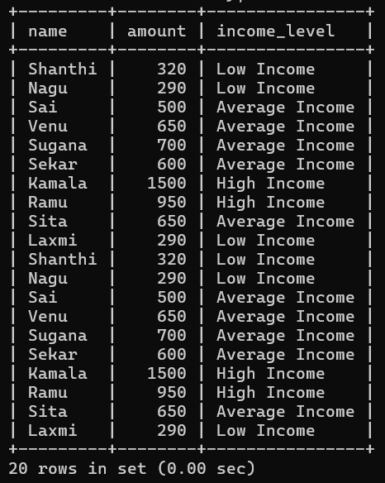

2 . REPEAT LOOP
Write a MySQL function using LOOP and ITERATE to repeatedly increase the amount of a milk supplier by 500 until the amount becomes greater than or equal to 2000. Once the amount reaches 2000 or more, terminate the loop and return the final amount.

DELIMITER //

CREATE FUNCTION increase_amount(amt INT)
RETURNS INT
DETERMINISTIC
BEGIN

amount_loop: LOOP

IF amt >= 2000 THEN
LEAVE amount_loop;
END IF;

SET amt = amt + 500;

ITERATE amount_loop;

END LOOP amount_loop;

RETURN amt;
END //

DELIMITER ;

SELECT name, amount, increase_amount(amount) AS final_amount
FROM milka_dairy;

OUTPUT:

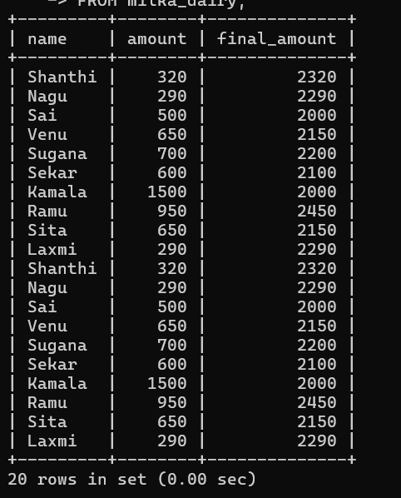

RESULT: Thus the Simple programming exercise using (CASE, LOOP )executed successfully.

